Injectable hydrogel boosts stem cell therapy to restore vision, repair brain damage

Friday 15 May 2015 at 8am PST

A new study reveals how an injectable "hydrogel" boosted stem cell transplantation to aid brain recovery following stroke and helped partially reverse blindness in mice.

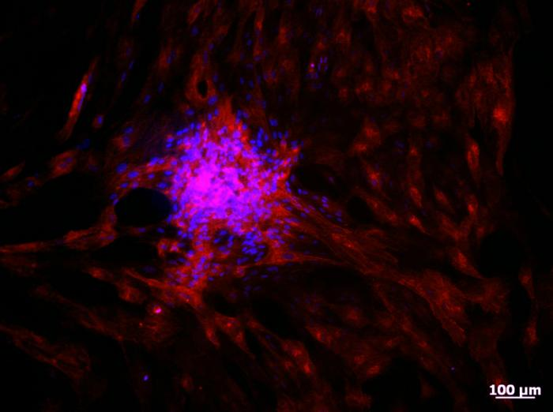

By injecting hydrogel-encapsulated photoreceptor cells (pictured) into the eyes of blind mice, the researchers partially restored vision.
Study leaders Molly Shoichet and Derek van der Kooy, of the University of Toronto in Canada, and colleagues publish their findings in the journal Stem Cell Reports.
Stem cell therapy has become a major focus in medical research - particularly tissue regeneration - primarily because stem cells have the ability to become any other cell type in the body.
In March, for example, Medical News Today reported on a study detailing how stem cells therapy could one day be used to treat osteoarthritis. The researchers of that study transformed human embryonic stem cells into cartilage cells, which successfully repaired damaged cartilage after being transplanted into the knee joints of rats.
However, the University of Toronto team note that when it comes to stem cell transplantation, there are some problems. They explain that while scientists can successfully grow stem cells in a lab dish, once left to their own devices after being transplanted into the body, stem cells often die or find it hard to fuse with surrounding tissue.
The researchers previously developed an injectable gel-like material, or "hydrogel," to tackle this issue. The hydrogel consists of two compounds: methylcellulose and hyaluronan. Methylcellulose forms a gel to hold the stem cells together during delivery to the transplant site, while hyaluronan works to ensure the stem cells survive.
"Through this physical blend of two materials we are getting the best of both worlds," says Shoichet.
For their study, the team set out to test how the hydrogel may benefit stem cell transplantation for nerve cell damage caused by disease or injury.

Findings 'bring stem-cell based therapy closer to reality'
Firstly, the researchers grew photoreceptors - light-sensitive cells in the eye's retina that are responsible for vision - from stem cells, before encapsulating them in the hydrogel and injecting them into the eyes of blind mice.
The researchers found that injecting these mice with the hydrogel-encapsulated photoreceptors successfully restored around 15% of their pupillary response, meaning their vision was partially restored.
Next, the team enveloped neural stem and progenitor cells in the hydrogel and injected them into the brains of mice that had brain damage due to recent stroke.
Within weeks, the mice demonstrated improvements in motor coordination, according to the researchers.
They now plan to test how the hydrogel-encapsulated neural cells affect rats with stroke injury, noting that rats have larger brains that are more appropriate for behavioral tests.
Commenting on their findings, Schoichet says:
The team adds that because they have shown the hydrogel increases the effectiveness of stem cell transplantation in both the eyes and the brain - two separate parts of the nervous system - it has the potential to boost the effectiveness of such therapy across of wide range of body regions.
What is more, they say that once the hydrogel has delivered stem cells to the required destination, it dissolves and the body reabsorbs it within a matter of weeks.
Injectable hydrogels may not only be useful for stem cell therapy. In February, Medical News Today reported on a study published in Nature Communications, in which researchers revealed the creation of an injectable hydrogel made of polymer-containing nanoparticles and cellulose that can deliver multiple drugs over long time periods.

